REPORT ON 2007 HURRICANE SEASON IN ST. LUCIA.

Despite above average cyclone activity during the 2008 hurricane season, the impact of adverse weather from tropical systems over Saint Lucia was confined to October and early November. Damage was caused by heavy rainfall and heavy sea swells generated by Hurricane Omar.

Rainfall
The worst damage from rainfall was due to an upper level trough interacting with a tropical wave (pre-cyclone phase of Hurricane Omar) resulting in a number landslides and periods of flooding mainly over the north of the island. The road network, public utilities and housing/infrastructure in flood prone areas suffered varying degrees of damage. Estimated cost of damage is XCD7.1 million.

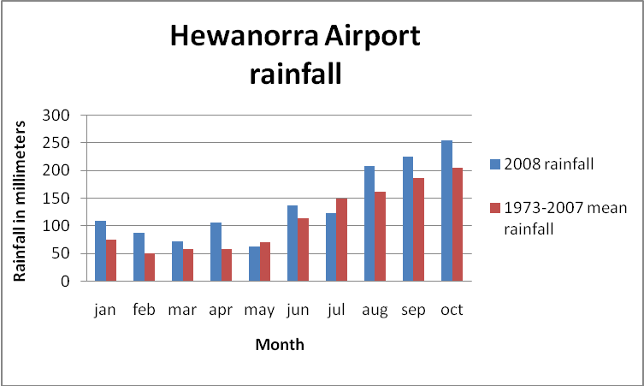

2008 Rainfall vs. 35 year mean for Hewanorra Airport weather station.

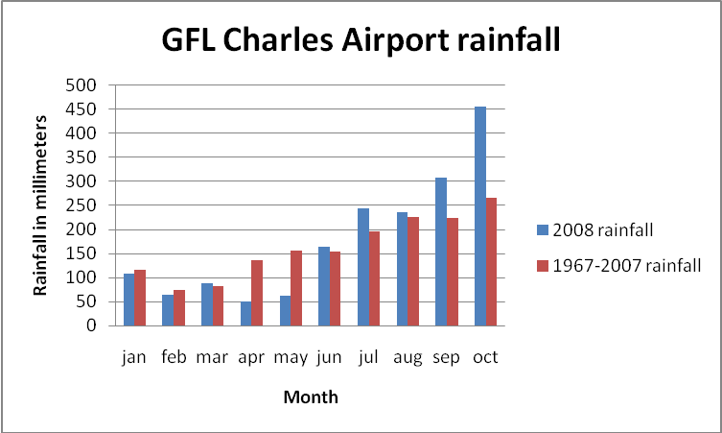

2008 Rainfall vs. 41 year mean for GFL Charles Airport weather station.

Hurricane Omar swells
Heavy seas generated by Hurricane Omar impacted mainly the north and west coasts of Saint Lucia on 16 October. The impact was most severe during the morning hours coinciding with the natural (astronomical) high tide. Approximately eleven waterfront homes and businesses in the town of Soufriere suffered moderate to severe damage. A number of residents of this town were housed in emergency shelters for a few days following the impact.

Casualities
There were no reports of weather related death or serious injury during this hurricane season.

Saint Lucia Met Services actions
The Met Services issued several ‘Severe Weather Warnings’ (SWW) during the hurricane season. SWW were issued prior to the onset of heavy rains and flooding in October.

SWW with a marine advisory component (small craft were asked to remain in port, etc) were also issued prior to the onset of heavy swells from Hurricane Omar on 16 October, 2008.

________________________________________________________________________

